Project Requirement – EDI orders
1 Reminder about the Goal of the project. - 2 -
1.1 Actual Situation - 2 -
1.2 Goal - 2 -
1.3 Limitations of the Project - 2 -
1.4 Requests with low priority (Not analyzed). - 2 -
1.5 Suggested Solution and Resources allocated. - 2 -
1.6 Phases and Implementation - 2 -
1.7 Difficulties Faced - 3 -
1.8 Impact on the actual Aria27 system - 3 -
1.9 Security Issues and user rights - 3 -
1.10 People involved in this project - 3 -
2 Solution - 4 -
2.1 Description of the Solution - 4 -
2.2 Time-wise Flow Chart - 4 -
2.3 Time and Charges - 4 -
2.4 Process 850 - 5 -
2.5 Update Orders. - 6 -
2.6 Assign one bulk to all or selected styles on temp. - 7 -
2.7 Find matching bulks/Distros: - 8 -
2.8 Processes Links - 9 -
2.9 Screens - 10 -
2.10 Process 850: - 10 -
2.10.1 Select Customer PO: - 11 -
2.10.2 Pack conflicts: - 13 -
2.11 Update Orders: - 15 -
2.11.1 Select Customer PO: - 15 -
2.11.2 Assign a Bulk/Distro: - 20 -
2.11.3 FindBulk/Distros: - 22 -

Reminder about the Goal of the project.

Actual Situation
- The “Main Control Screen” is used to handle all EDI transactions, both incoming and outgoing.
- For the incoming transactions a raw file is received and each transaction is processed.
- For the 850 transaction before processing a PO into temp all conflicts; like pack versions or selecting a bulk for a range pack; have to be resolved.
- After an order is brought into temp it can be updated into a final EDI order.
- During the update process a temp order can be depleted from one or more existing bulk order(s), the user is prompted to assign the qty and the bulk# for each item on the temp.

Goal
- The purpose of this project is to create an interface to handle 850 transactions.
  - Process a PO into temp.
  - Resolve version conflicts.
  - Deplete from bulk/distro.
  - Update temp

Limitations of the Project
- Handle the 850 transaction only.

Requests with low priority (Not analyzed).
- Depleting Manual orders.

Suggested Solution and Resources allocated.
Build a new interface to handle the 850 transaction.

Questions related to the solution:
- Do we have to display all bulks, or only those that have matching Qty?
- Can an order be depleted from a non-bulk?

Phases and Implementation
- Process PO into temp
- Resolve pack conflicts
- Deplete order
- Update order

Difficulties Faced
- Changing users’ habits

Impact on the actual Aria27 system
No Impact on Aria.

Security Issues and user rights
User rights will be managed from Aria.

People involved in this project
GMA: Elie as Project Manager
Eddie as Analyst
Hend as programmer

Solution

Description of the Solution

Time-wise Flow Chart
Acknowledge receipt
Day = D
Receive Raw File
Update Order
Process PO
Create temp
D + n
Deplete from Bulk/distro
Select bulk/distro and qty
Create EDI order

Time and Charges
Process | Screens | Analysis / Days | Development / Days
Depletion | Process 850
 | Select Customer PO | 3
 | Pack Conflicts | 3
 | Sub Total | 6
 | Update Order
 | Select Customer PO | 3
 | Assign a Bulk/Distro | 4
 | Find Bulks/Distros | 3
 | Sub Total | 10
 | Total | 16

Process 850

Goal
To process one or more PO(s) into temp order (s)

Rules of the process

Process PO Flow Chart

Process PO
Create Temp order
Select a range of Customer PO’s

Select Customer PO

Pack Conflict

Update Orders.

Goal
Update EDI and Web temp orders.

Rules of the process

Update an Order, Figure02
Select Temp
Assign a Bulk/Distro
Select Style
Find Bulks/Distros
Assign a Bulk/Distro

Assign one bulk/distro to all or selected styles on a temp.

Goal
To deplete from a specific bulk/distro in one step instead of entering the bulk/distro for each individual item on the temp.

Rules of the process

Assign bulk to temp, Figure03

Select Temp
Select and assign bulk
Update temp

Find Bulks/Distros:

Goal
Search for existing bulks/distros that match specific criteria.

Rules of the process

Help extract existing bulks, Figure04
Find Bulks/Distros
Enter Searching Criteria
Display all Matching bulks/distros
Deplete
Update

Processes Links

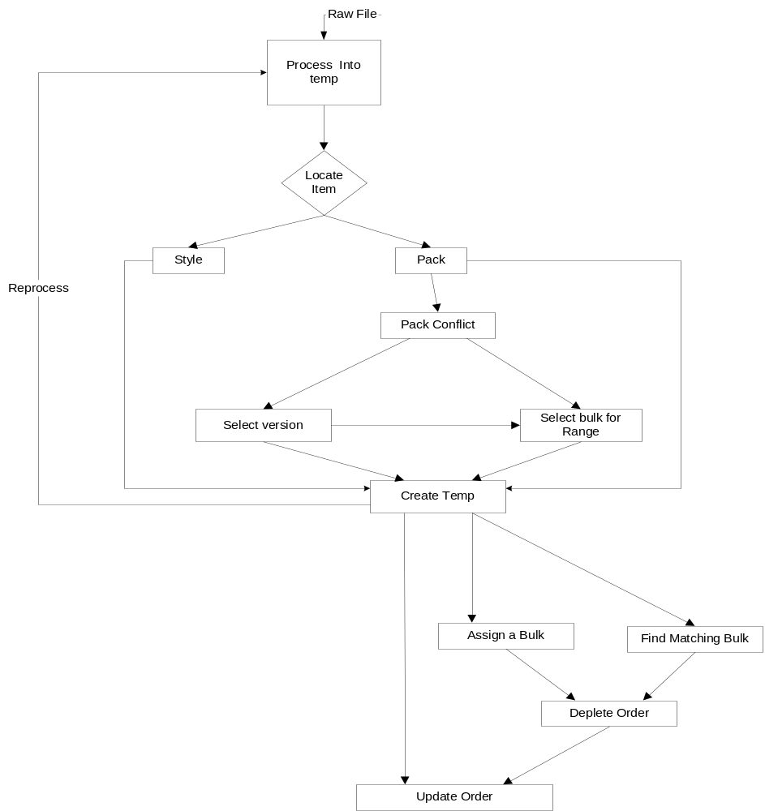

Screens

- Process 850
  - Select Customer PO
  - Pack Conflicts
- Update Order
  - Select Customer PO
  - Assign a Bulk/Distro
  - Find Bulks/Distros

Process 850:

The aim behind this screen is to process PO’s into temp orders. Only un-updated 850 incoming transactions will be displayed. The screen is mainly divided into two folders: Select Customer PO and Pack Conflicts
Field description (displayed for the selected record):
- File#: Incoming file number.
- PO#: Customer PO number.
- Account: Account code.
- Order#: temp order # incase PO was processed.
- PO Status: can be one of three values depending on PO status; “Accepted when processed”, “Processed into temp”, “Rejected when processed”

Select Customer PO:

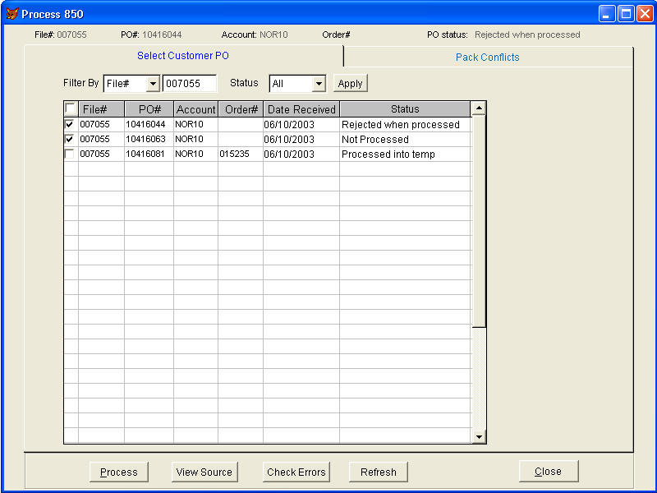

Field description:
- Filter By: This dropdown will be used to filter data on:
- All: All files and all un-updated PO’s will be displayed; data will be sorted by File# (Descending), account, PO#.
- File# (default): Data will be filtered on the value entered for the file#; for example; 007055. By default the last received file will be displayed.
- Account: Data will be filtered on the value entered for the account code; for example; TAR10.
- PO#: Data will be filtered on the value entered for the PO#; for example; 022-3389.
- Status: This is a dropdown to further filter the data based on status of PO, user can select:
- Both (default): This will display both Processed and Unprocessed PO’s.
- Unprocessed: Data will be filtered on Unprocessed PO’s.
- Processed: Only PO’s that were processed will be displayed.
- Rejected: Filter on rejected PO’s.

Button description:
Apply: Applies the selected criteria.
Process: Processes/Re-Processes selected PO(s).
View Source: Displays the raw data for the selected PO.
Check Errors: Displays the processing errors for the selected PO(s) if any; otherwise; the button should be disabled.
Refresh: Refreshes the data by applying the selected criteria.

Gird:
Check box in grid header: Selects/unselects all records currently displayed in the grid.
File#: Incoming file number
PO#: Customer PO number
Account: Account Code
Order#: temp order number
Date Received: Date the incoming file was received.

Pack conflicts:

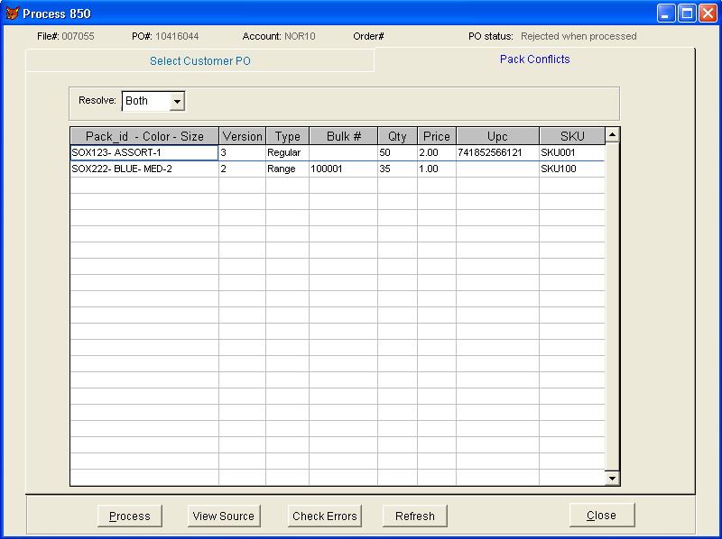

The aim behind this screen is to resolve Pack conflicts:
- This screen will replace the “Pack conflict” screen.
- It is accessible for temp orders with pack version or Range pack conflicts only.
- It will be used to:
  - Resolve pack version conflicts for the selected PO; incase a received pack has more than one version.
  - Assign a bulk to a range pack in order to determine the quantity for each ordered style upon processing the PO.
- The user can resolve the conflicts and then reprocess a PO.

Field description:
- Resolve: Used to filter the packs; the user can select to work on resolving: Version conflicts, Range conflicts or both.
- Version: A dropdown populated with all available versions for this pack.
- Type: this is the pack type (Range; Regular)
- Bulk#: User can enter bulk number incase pack is a range. Upon selecting a bulk order to deplete from the following has to be taken into consideration:
- Only qty of pieces on bulk has to match ordered qty, no need to check for dates.
- We need to take the bulk qty assigned to temp orders into account, i.e. bulk qty available is calculated and it should be (Qty on bulk minus depleting temp orders qty). So, the matching is to be based on the available bulk qty rather than the whole qty on the bulk. The reason for that is; some times a bulk is selected for a range; however; the order is still as temp and the bulk qty is not updated and it is not the actual available qty.
- Qty: Incase the pack is a range display qty of pieces; display qty of packs otherwise.

Update Orders:

Select Customer PO:

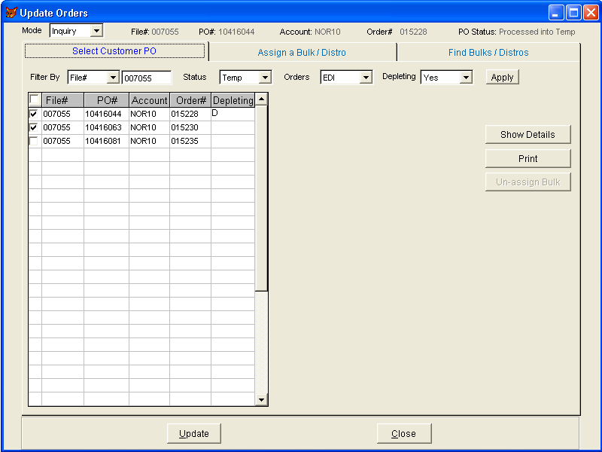

The aim behind this screen is to update temp orders and deplete from bulks or distros (a distro is a regular order by stores). Only temp orders will be displayed, however, the update process should treat web temp orders (orders that were created from our website WebSO) as a special case, since the same order number has to be carried over; for example; suppose there is a web temp order# 123456 then it should be updated into a final order with the same number i.e. 123456.
Depletion from a bulk or a distro works under four modes:
- Inquiry (default): In this mode the user can inquire about bulks/distros or search for existing bulks/distros that match selected criteria. It is more like a help and the user can NOT assign/un-assign a bulk. In order assign/un-assign a bulk; the user will have to switch to any of the below modes. For example, a user would select one or more styles from a temp then go to “Find matching bulks/Distros” and the system displays all bulks that match the default criteria for these styles or the user can change the searching criteria and find other bulks/distros, if the user decides to deplete from any of these bulks/distros then s/he has to switch the mode and then assign the bulk.
- 1 to1: One temp will be depleted from one bulk; in this case the user is allowed to select one temp only and then assign one bulk from “Assign a Bulk/Distro” screen. “Find matching bulks/Distros” tab will be disabled
- 1 to N: One temp will be depleting from one or more bulks/distros. The user is allowed to select only one temp in this case and assign the bulks/distros from the “Find matching bulks/Distros” screen. “Assign a Bulk/Distro” will be disabled. The user should not be allowed to select this mode if s/he is in the “Assign a Bulk/Distro” screen and more than one temp is selected.
- N to 1: One or more temps will be depleting from one bulk; the bulk will be assigned from the “Assign a Bulk/Distro” screen. “Find matching bulks/Distros” will be disabled. The user should not be allowed to select this mode if s/he is in the “Find matching bulks/Distros” screen.

Field description:
- Filter By: This dropdown will be used to filter data on:
- All: All files and all temp orders will be displayed.
- File#: Data will be filtered on the value entered for the file#; for example; 007055. By default the last file received will be displayed.
- Account: Data will be filtered on the value entered for the account code; for example; TAR10.
- PO#: Data will be filtered on the value entered for the PO#; for example; 022-3389.
- Status: This is a dropdown to further filter the data based on status of PO, user can select:
- All: This will display both temp and updated orders.
- Temp (default): Only PO’s that were processed into temp orders will be displayed.
- Updated: Data will be filtered on updated orders.
- Orders: This is a dropdown to further filter the data based on the order type, user can select:
- EDI (default): only EDI temp orders will be displayed.
- Web: only Web temp orders will be displayed. Note that Web orders don’t come in a raw file and hence File# is blank.

Grid:
Depleting: The temp order is depleting “D” from one or more bulks/distros, this field is left blank if the order is not depleting.
Button description:
Show Details: Displays the details of the temp order, one order can be selected at a time.
Apply: Refreshes the data by applying the selected criteria.
Un-Assign Bulk: Releases the bulk and marks the temp as non-depleting; enabled for temp orders only and it the order is depleting.
Print: Displays a preview of data in the grid (Same layout for any of the options below) and the user can print it.
Update: Updates selected PO(s) into EDI orders; enabled for temp orders only.
Temp order details:
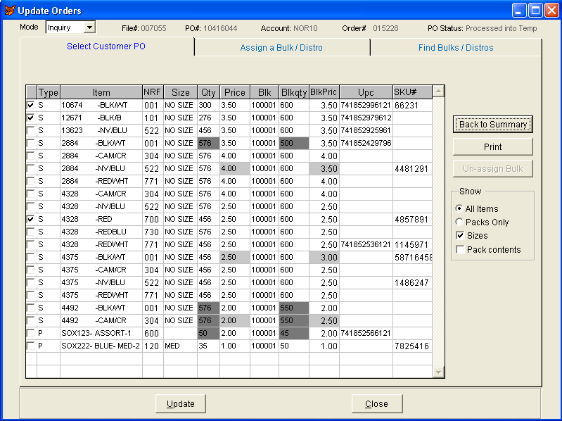

  - Data will be consolidated by store.
  - Back to Header: Hides the temp order details and displays the previous screen.
  - All un-matching quantities and/or prices will be highlighted.
Show sizes (check box): Displays one size per row and the corresponding UPC, when it is unchecked the styles are consolidated by style/color or pack key and the total qty is displayed (see below snapshot):
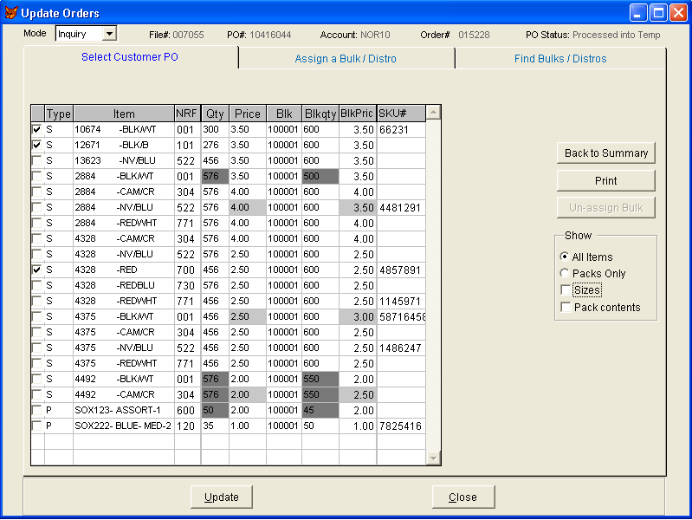
Show pack contents (check box): Displays the pack contents and adds a new column to the grid to display the pack key.
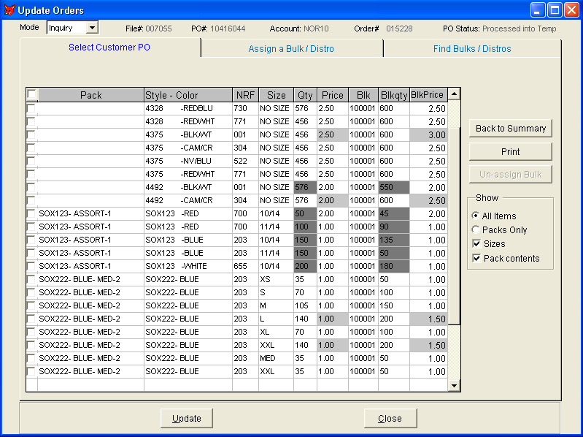

Show all items: Displays all the details of this temp order.
Show packs only: Displays packs only.

Assign a Bulk/Distro:

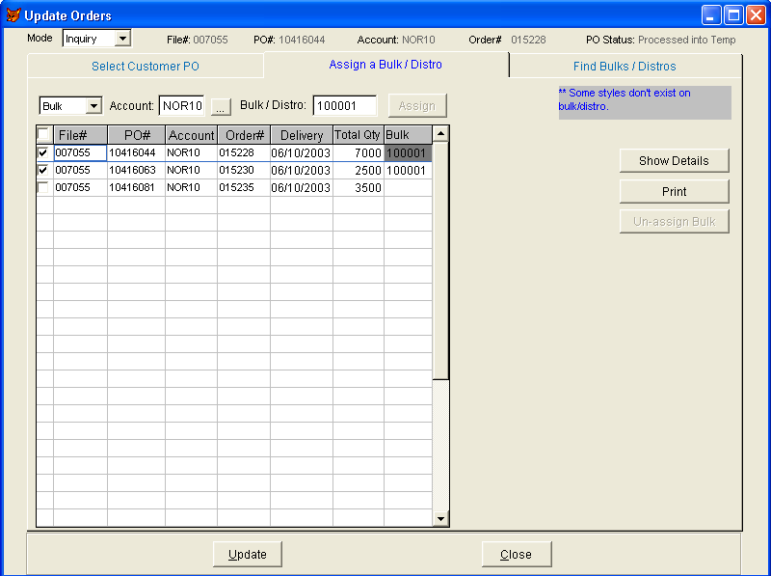

The purpose of this screen is to select a bulk/distro and assign it to one or more temps, in this case we have a temp order and the user will assign one bulk/distro from which quantities will be depleted.
  - When the “Assign a Bulk/Distro” tab is clicked; all temp orders selected in “Select Customer PO”; will be displayed.
  - The user types in the bulk/distro order number, or alternatively enters “?” and the system displays a list of open bulk/distros for this account (excluding completed/cancelled orders should be excluded). The user can then select one bulk/distro and click “Assign”, the system will assign the bulk/distro # to each of the items on the temp.
  - The selected bulk/distro will be assigned to each of the items even if the bulk qty is less than the ordered qty. On update the system will split this line into 2, one will deplete from the bulk/distro and the remaining qty will go into the second line and will be deducted from inventory.
  - The system will display one of the following messages:
    - ** Some styles don’t exist on bulk/distro.
    - ** Bulk order was successfully assigned to all items
    - ** Bulk order was assigned to none of the items due to style mismatch.
  - Any bulk/distro with mismatching qty/price will be highlighted.
Field description:
- Account: by default this is the account code of the temp order, however, the user can change it to any other account code.
- Bulk/Distro: The user can enter or select (from a browse) a bulk/distro order for this account (excluding completed/cancelled orders should be excluded).
Button description:
- Assign: Assigns this bulk to the selected PO’s.
- Un-Assign Bulk: Releases the bulk order for the selected items (from grid); enabled when bulk/distro is assigned. Should be disabled in “Inquiry” mode.
- Show Details: Displays the temp order details (see below snapshot):
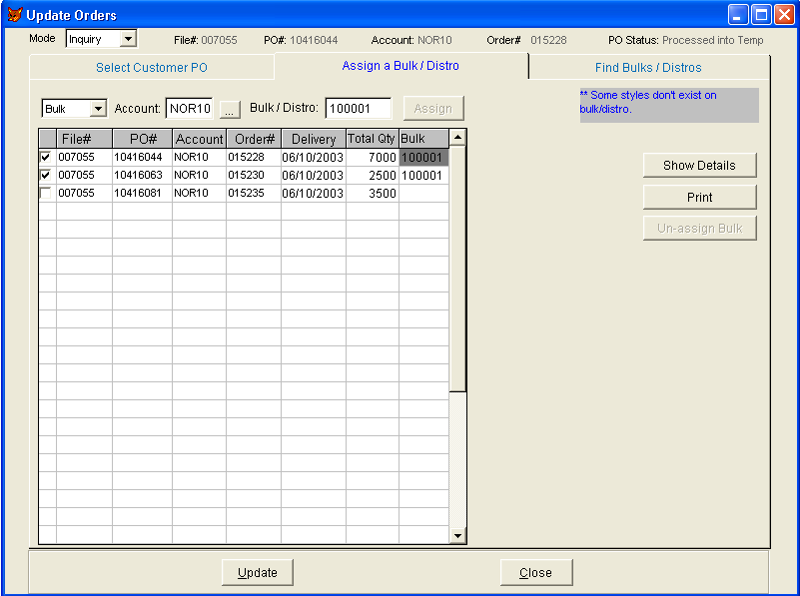

  - Mismatching qty/price will be highlighted.
  - Data will be consolidated by store.
  - Only styles and non-range packs will be displayed in the grid.
  - Back to Summary: Hides the temp order details and displays the previous screen.
  - Show size (check box): Displays one size per row and the corresponding UPC, when it is uncheck the items are consolidate by style/color or pack key and the total qty is displayed.
  - Pack Contents: Displays the pack contents and adds a new column to the grid to display the pack key.

Find Bulks/Distros:

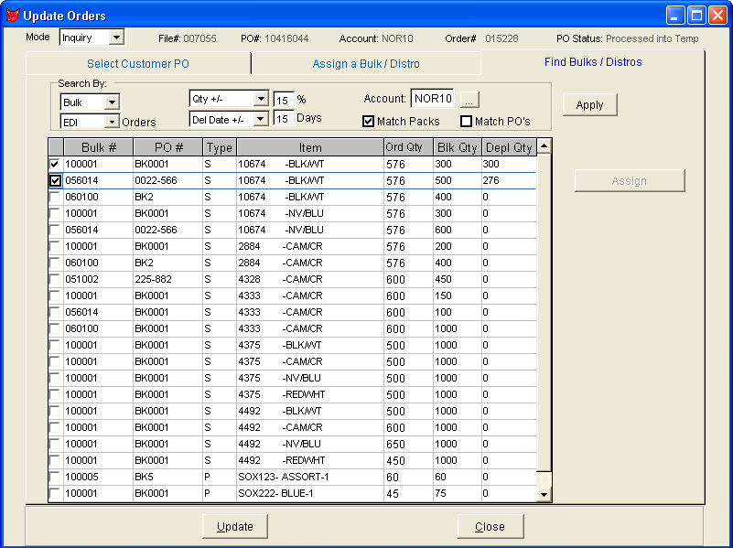

The aim behind this screen is to locate bulks/distros that match items on a selected temp order. The user can also use this screen to find any bulks/distros that contain the specified styles. This screen is accessible through the “Select Customer PO” screen; the user has to select one non-Depleting temp order and then click “Find Bulks/Distros” the system will display all matching bulks by applying the default search criteria. Incase the user selects specific styles from the “Select Customer PO” tab then the system will search bulks/distros for these styles only. When the user selects a style from a bulk/distro the system automatically assigns the “Depl Qty”; the user can optionally change it. “Depl Qty” is the remaining temp qty that need to deplete from bulk qty.

Field description:
- Search By: These will determine the options to search for bulks:
- First option: User can select one of three values:
  - Bulk (Default): Search for bulk orders only.
  - Distro: Search for non-bulk orders only.
  - All: Search for
- Second Option:
  - All Orders (Default): Both EDI and non-EDI orders.
  - EDI: EDI orders only.
  - Non-EDI: non-EDI orders only.
- Third Option:
  - Any Qty: No restriction on Qty.
  - Qty +/- 15%: The bulk qty should be +/- 15% the qty on temp.
- Fourth Option:
  - Del Dates: Bulk order complete date should match temp complete date.
  - Del Dates +/- 15 days: Bulk order complete date should match temp complete date +/- 15 days.
- Match packs: When this option is checked the system has to match the pack key for both the temp and the bulk/distro, otherwise neglect the pack key when this option is unchecked and match the styles only even if the style comes in a pack.
- Match PO’s: Bulk order customer PO should match temp order customer PO.
- Account: Search for bulks that belong to the selected account code.
Button description:
Apply: Refreshes the screen by applying the “Search By” criteria.
Assign: Assigns selected bulks to selected styles, marks the order as depleting, and opens the “Select Customer PO” tab.

Depleting from a Distro:
When depleting from a distro we have to treat it as a bulk by depleting sequentially (style by style) from the distro. And the allocation has to be moved to the new order.

